Blob Maintenance with Azure Functions
Student Lab: Timer Triggers, HTTP Triggers & Automated Blob Archiving
All commands use Windows Command Prompt (cmd.exe) | Fresh start — no prior lab required

Lab Overview
In this lab you will build a serverless Blob maintenance service using Azure Functions. A Timer Trigger function will automatically move files older than 7 days from an uploads container to an archive container every night at midnight. An HTTP Trigger function gives you an on-demand way to run the same logic — perfect for testing. All Azure resources are created fresh from the command line.

What You Will Build
Lab | Goal
Lab 1: Setup | Sign in to Azure CLI, set variables, create the resource group
Lab 2: Storage | Create a storage account with uploads and archive containers
Lab 3: Key Vault | Store the storage connection string securely in Key Vault
Lab 4: Function App | Scaffold a .NET 8 isolated-worker Function App project
Lab 5: Timer Trigger | Write a function that archives old blobs on a nightly cron schedule
Lab 6: HTTP Trigger | Write an on-demand function that triggers the same archive logic
Lab 7: Test Locally | Run the Function App locally and test both functions with curl
Lab 8: Deploy to Azure | Create a Function App in Azure, connect Key Vault, and deploy
Lab 9: Cleanup | Delete all resources with a single command

Prerequisites — Install These First
- Azure CLI — confirm with: az --version
- .NET SDK 8.0 or later — confirm with: dotnet --version
- Azure Functions Core Tools v4 — install once with the command below, then confirm with: func --version
npm install -g azure-functions-core-tools@4 --unsafe-perm true
Tip
If npm is not installed, download Node.js from https://nodejs.org — the LTS version includes npm. After installing Node.js, reopen cmd.exe and run the npm command above.
Important
Keep ONE cmd.exe window open for the entire lab. Variables set with the set command only last for the current session — if you close the window you must re-run the set commands from Lab 1 using your original SUFFIX value.

Lab 1: CLI Setup

Step 1 — Sign In
- Run az login. A browser window will open — sign in with your Azure account.
az login

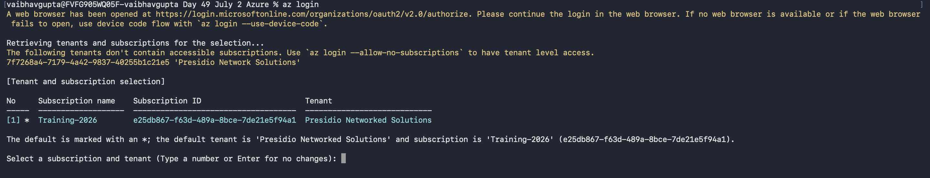

Step 2 — Set Variables
- Type each line exactly. No spaces around the = sign.
set RG=func-lab-rg
set LOCATION=eastus
set /A SUFFIX=%RANDOM%
set SA_NAME=funclabsa%SUFFIX%
set KV_NAME=func-lab-kv-%SUFFIX%
set FUNC_NAME=func-lab-app-%SUFFIX%
set CONTAINER_UPLOADS=uploads
set CONTAINER_ARCHIVE=archive
- Confirm your values printed correctly:
echo %SA_NAME%
echo %KV_NAME%
echo %FUNC_NAME%

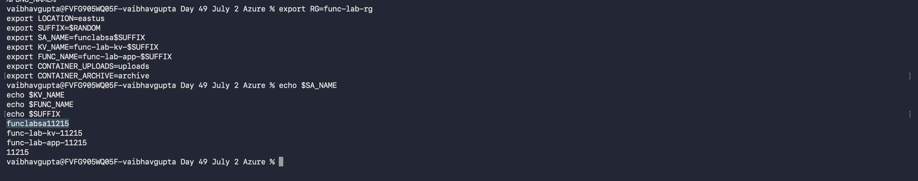

Write your values here — you will need them if you ever need to restore the variables:
SA_NAME value | funclabsa11215

KV_NAME value | func-lab-kv-11215

FUNC_NAME value | func-lab-app-11215

SUFFIX value | 11215

Step 3 — Create the Resource Group
az group create --name %RG% --location %LOCATION%

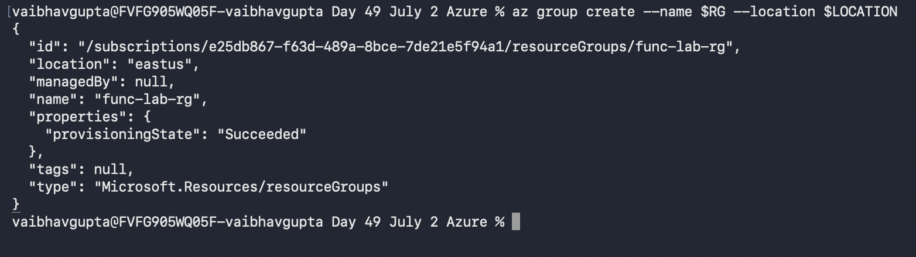

Lab 2: Storage Account
The function will move blobs between two containers: uploads (where files land) and archive (where old files go). Both containers live in the same storage account.

Step 1 — Create the Storage Account
az storage account create ^
--name %SA_NAME% ^
--resource-group %RG% ^
--location %LOCATION% ^
--sku Standard_LRS ^
--kind StorageV2

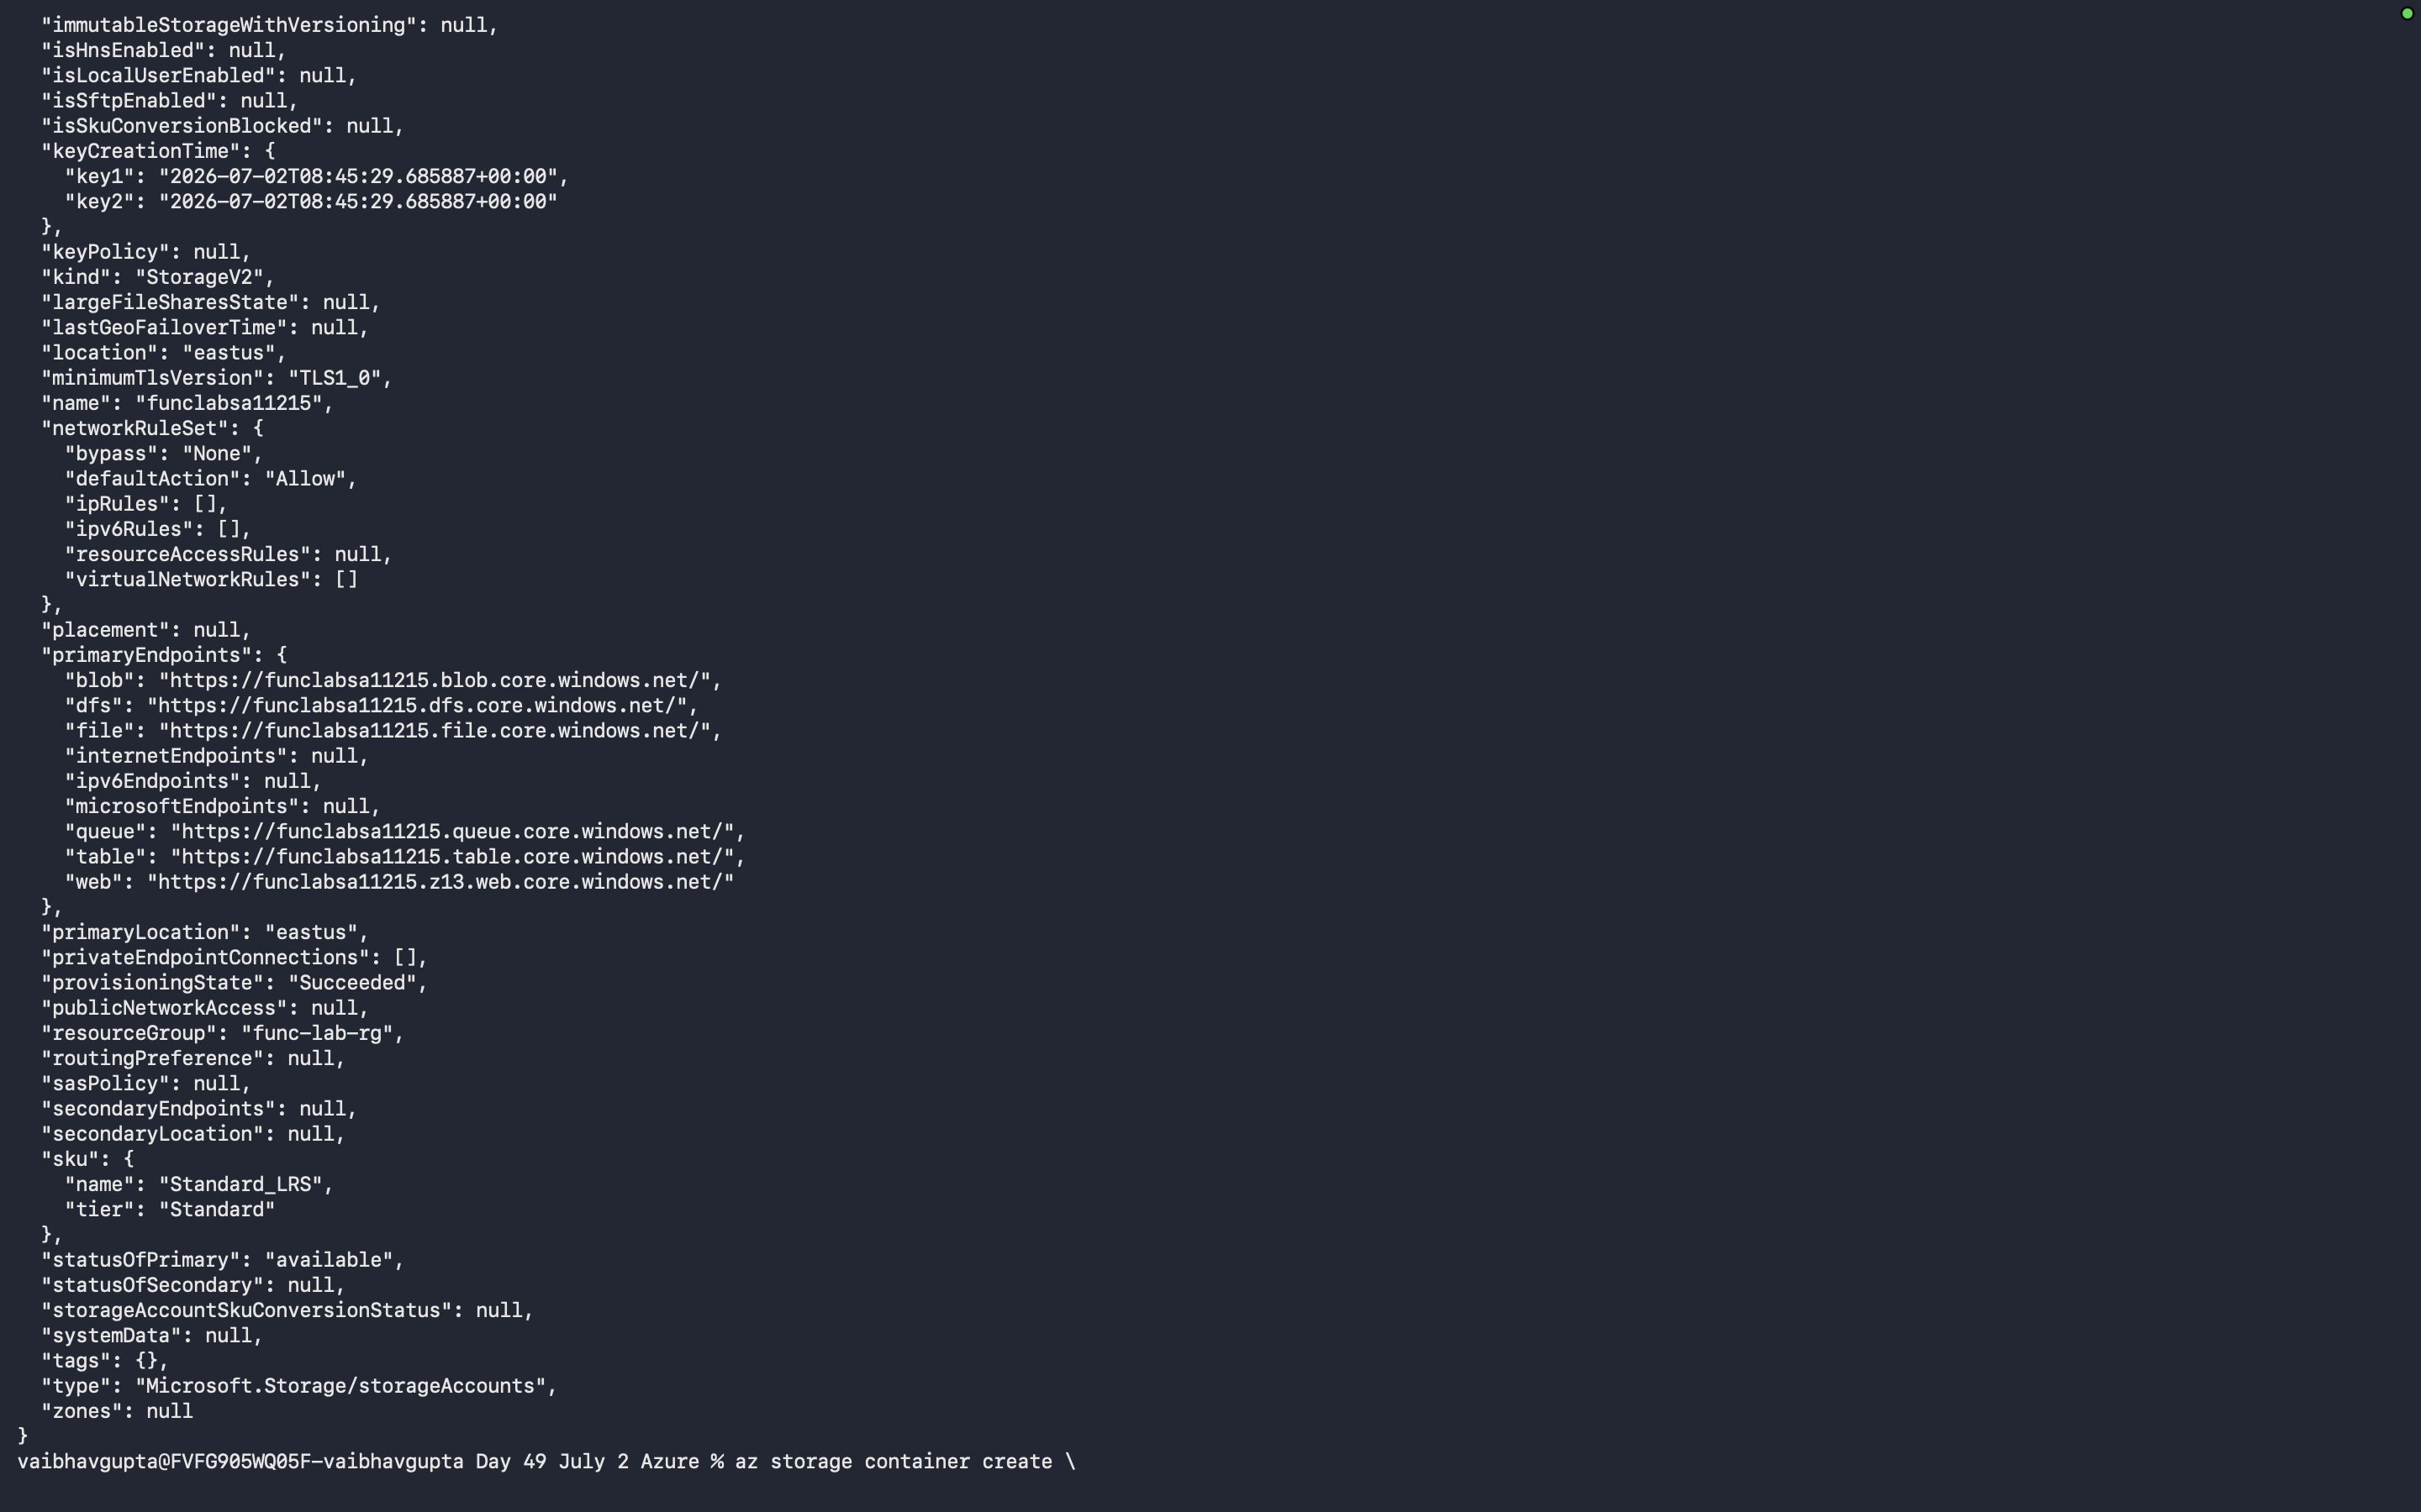

Step 2 — Create the Two Containers
az storage container create ^
--name %CONTAINER_UPLOADS% ^
--account-name %SA_NAME% ^
--auth-mode login

az storage container create ^
--name %CONTAINER_ARCHIVE% ^
--account-name %SA_NAME% ^
--auth-mode login

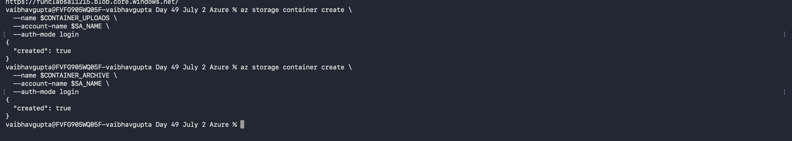

Step 3 — Capture the Connection String
for /f "delims=" %a in ('az storage account show-connection-string --name %SA_NAME% --resource-group %RG% --query connectionString -o tsv') do set CONN_STRING=%a
Tip
Verify it was captured: echo %CONN_STRING% — it should start with DefaultEndpointsProtocol=https
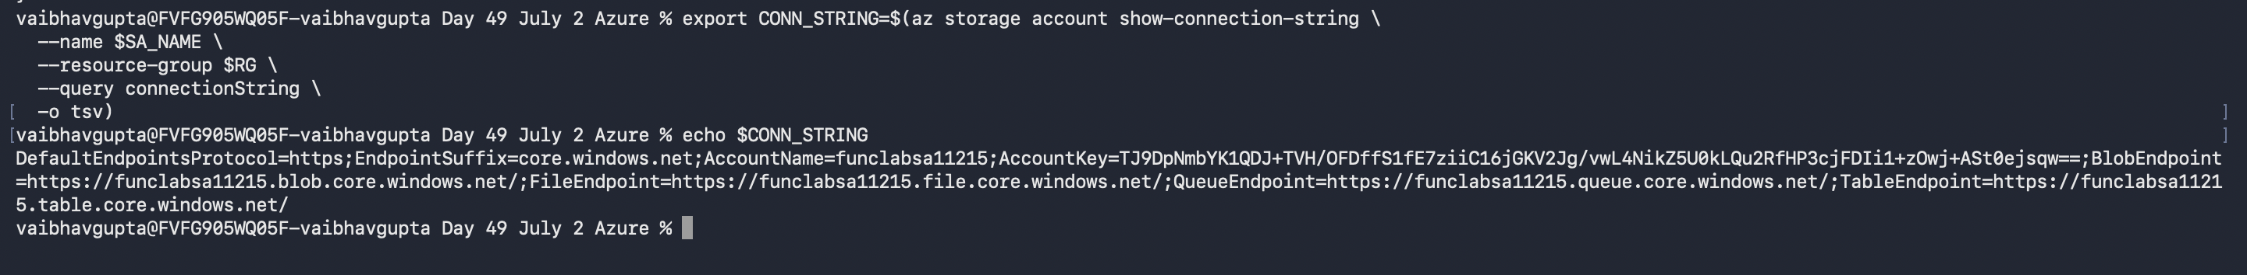
DefaultEndpointsProtocol=https;EndpointSuffix=core.windows.net;AccountName=funclabsa11215;AccountKey=TJ9DpNmbYK1QDJ+TVH/OFDffS1fE7ziiC16jGKV2Jg/vwL4NikZ5U0kLQu2RfHP3cjFDIi1+zOwj+ASt0ejsqw==;BlobEndpoint=https://funclabsa11215.blob.core.windows.net/;FileEndpoint=https://funclabsa11215.file.core.windows.net/;QueueEndpoint=https://funclabsa11215.queue.core.windows.net/;TableEndpoint=https://funclabsa11215.table.core.windows.net/

Lab 3: Key Vault
The connection string will be stored in Key Vault. In Azure, the Function App will read it via a Key Vault Reference — a special app setting syntax that tells Azure to fetch the value from Key Vault automatically, with no code changes needed.

Step 1 — Create the Vault
az keyvault create ^
--name %KV_NAME% ^
--resource-group %RG% ^
--location %LOCATION%

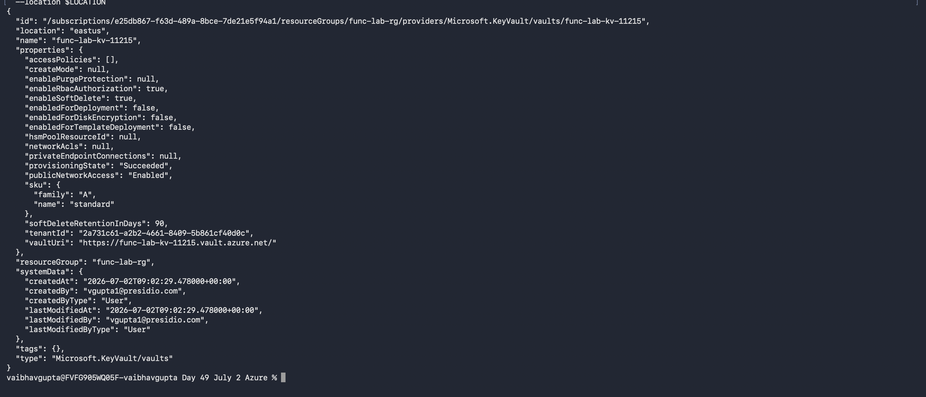

Step 2 — Grant Yourself Access
- Capture your Azure AD object ID and set an access policy:
for /f "delims=" %a in ('az ad signed-in-user show --query id -o tsv') do set MY_OID=%a

az keyvault set-policy ^
--name %KV_NAME% ^
--object-id %MY_OID% ^
--secret-permissions get set list delete

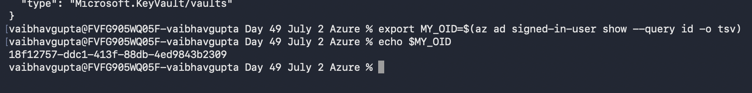

Step 3 — Store the Connection String
az keyvault secret set ^
--vault-name %KV_NAME% ^
--name "BlobStorageConnectionString" ^
--value "%CONN_STRING%"

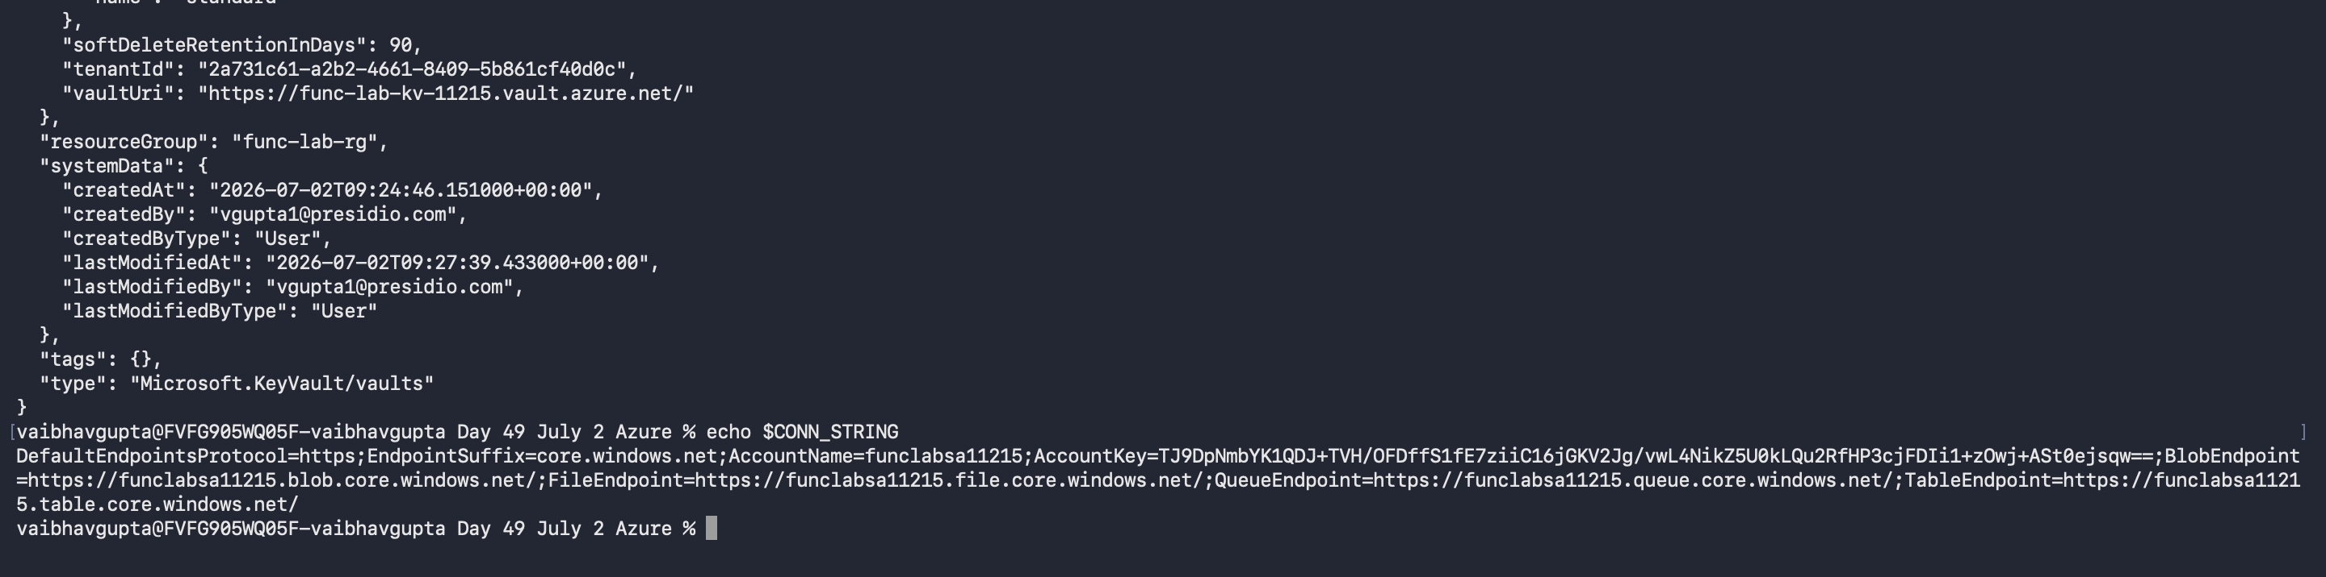

Important
This is the last time the connection string is handled directly. From this point the secret lives only inside Key Vault.
DefaultEndpointsProtocol=https;EndpointSuffix=core.windows.net;AccountName=funclabsa11215;AccountKey=TJ9DpNmbYK1QDJ+TVH/OFDffS1fE7ziiC16jGKV2Jg/vwL4NikZ5U0kLQu2RfHP3cjFDIi1+zOwj+ASt0ejsqw==;BlobEndpoint=https://funclabsa11215.blob.core.windows.net/;FileEndpoint=https://funclabsa11215.file.core.windows.net/;QueueEndpoint=https://funclabsa11215.queue.core.windows.net/;TableEndpoint=https://funclabsa11215.table.core.windows.net/

Lab 4: Scaffold the Function App

Step 1 — Create the Project
- Choose a folder on your machine to work in, then cd into it.
- Run the following to create the Function App project:
func init BlobArchiveFunctions --worker-runtime dotnet-isolated --target-framework net8.0
cd BlobArchiveFunctions
Tip
func init creates a .csproj file, a Program.cs, a host.json, and a local.settings.json. The dotnet-isolated model is the modern .NET approach for Azure Functions.

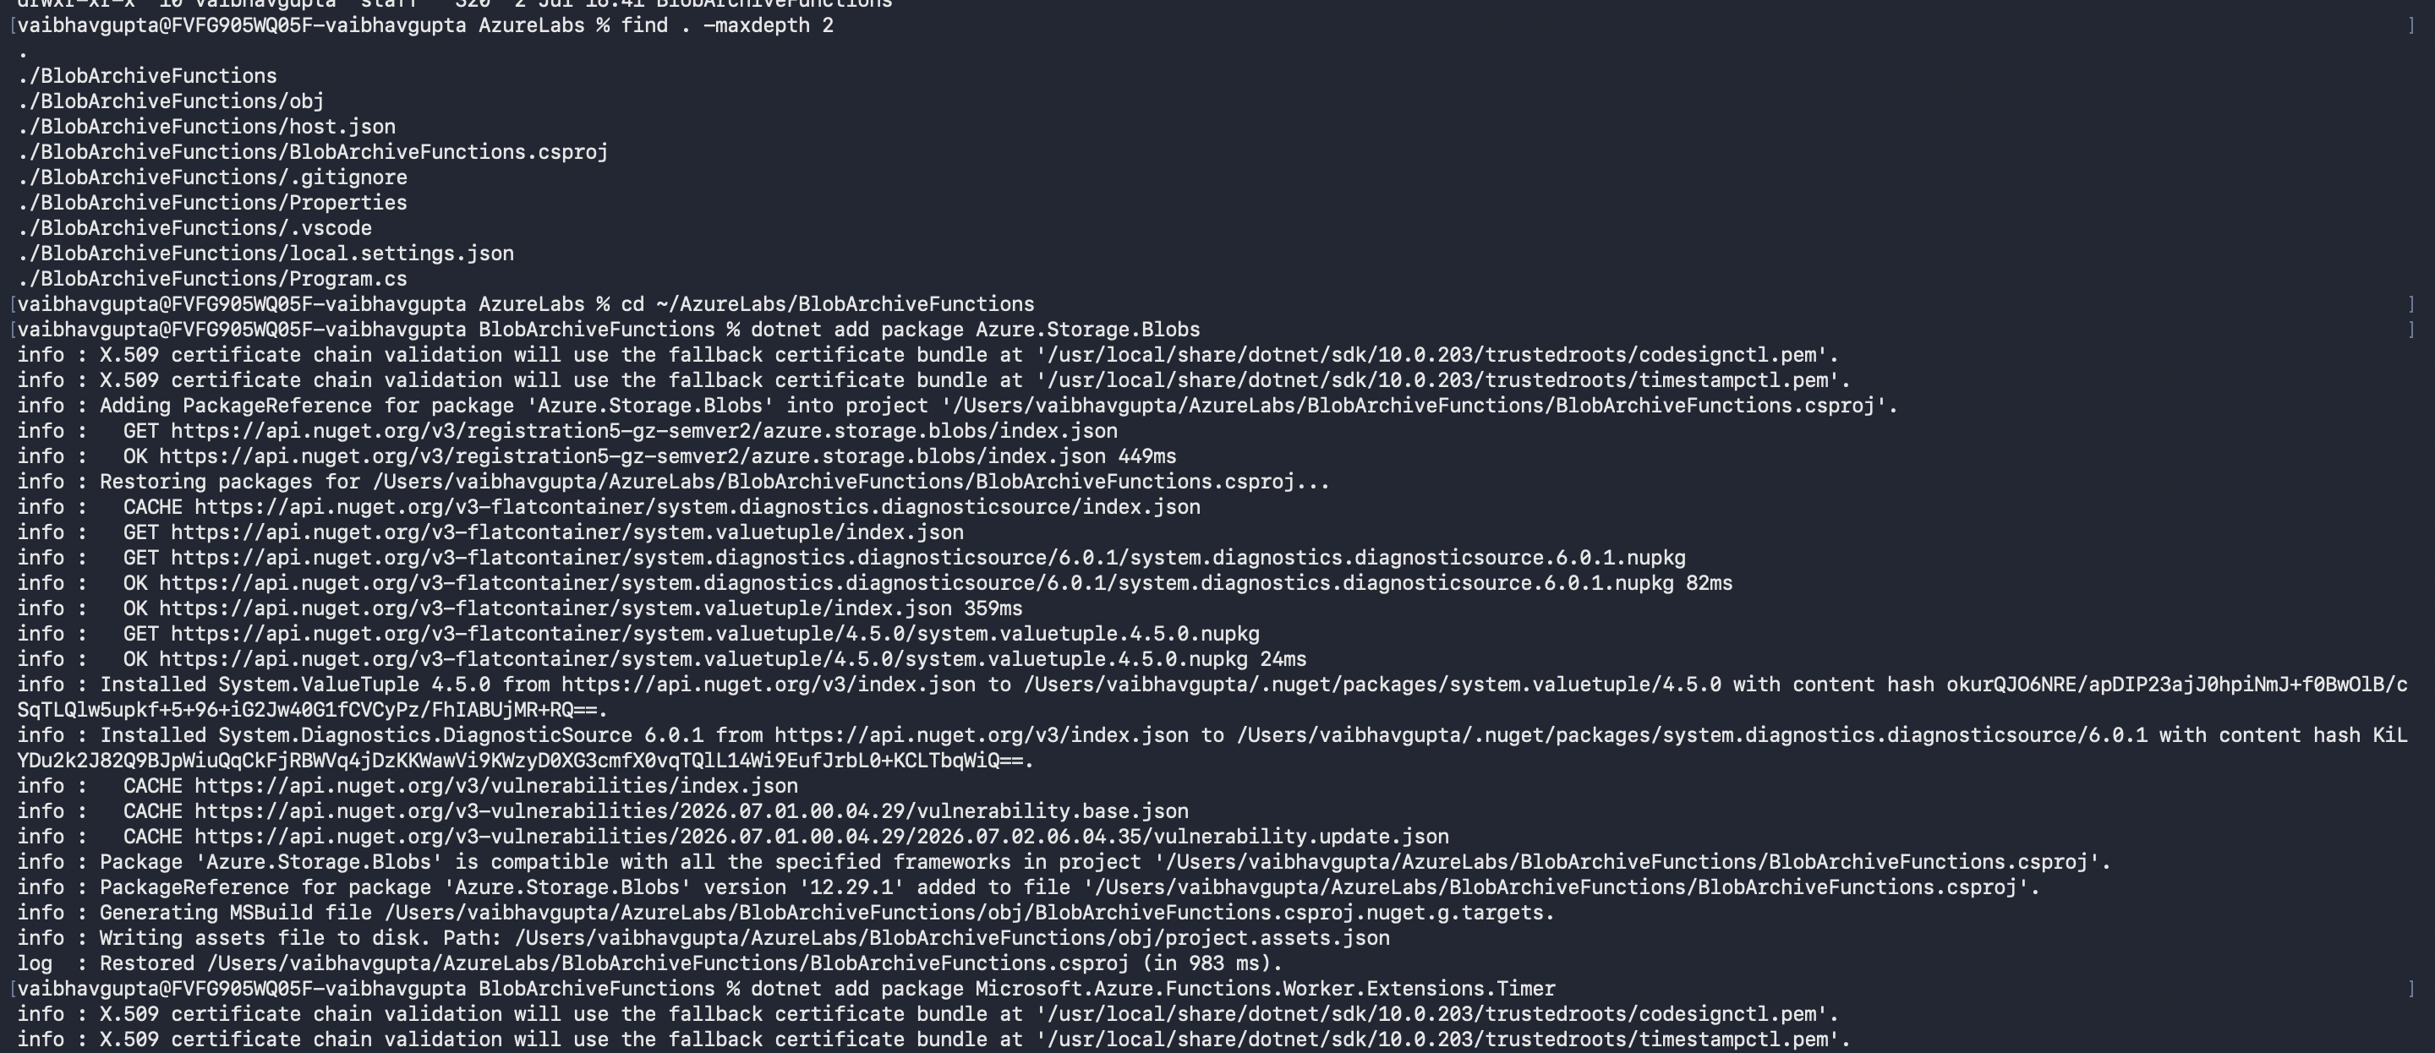

Step 2 — Add the Blob Storage Package
dotnet add package Azure.Storage.Blobs

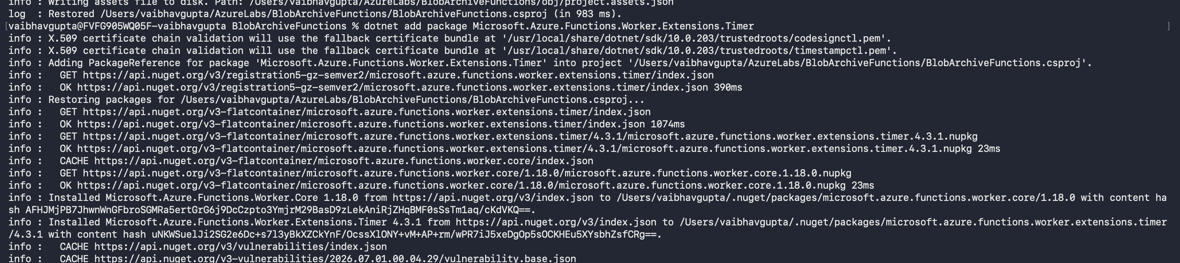

Step 3 — Add the Timer Extension
dotnet add package Microsoft.Azure.Functions.Worker.Extensions.Timer

Step 4 — Create the Function Files
- Add the Timer Trigger function file:
func new --name NightlyArchive --template "Timer trigger" --language C#
- Add the HTTP Trigger function file:
func new --name ManualArchive --template "HTTP trigger" --language C#

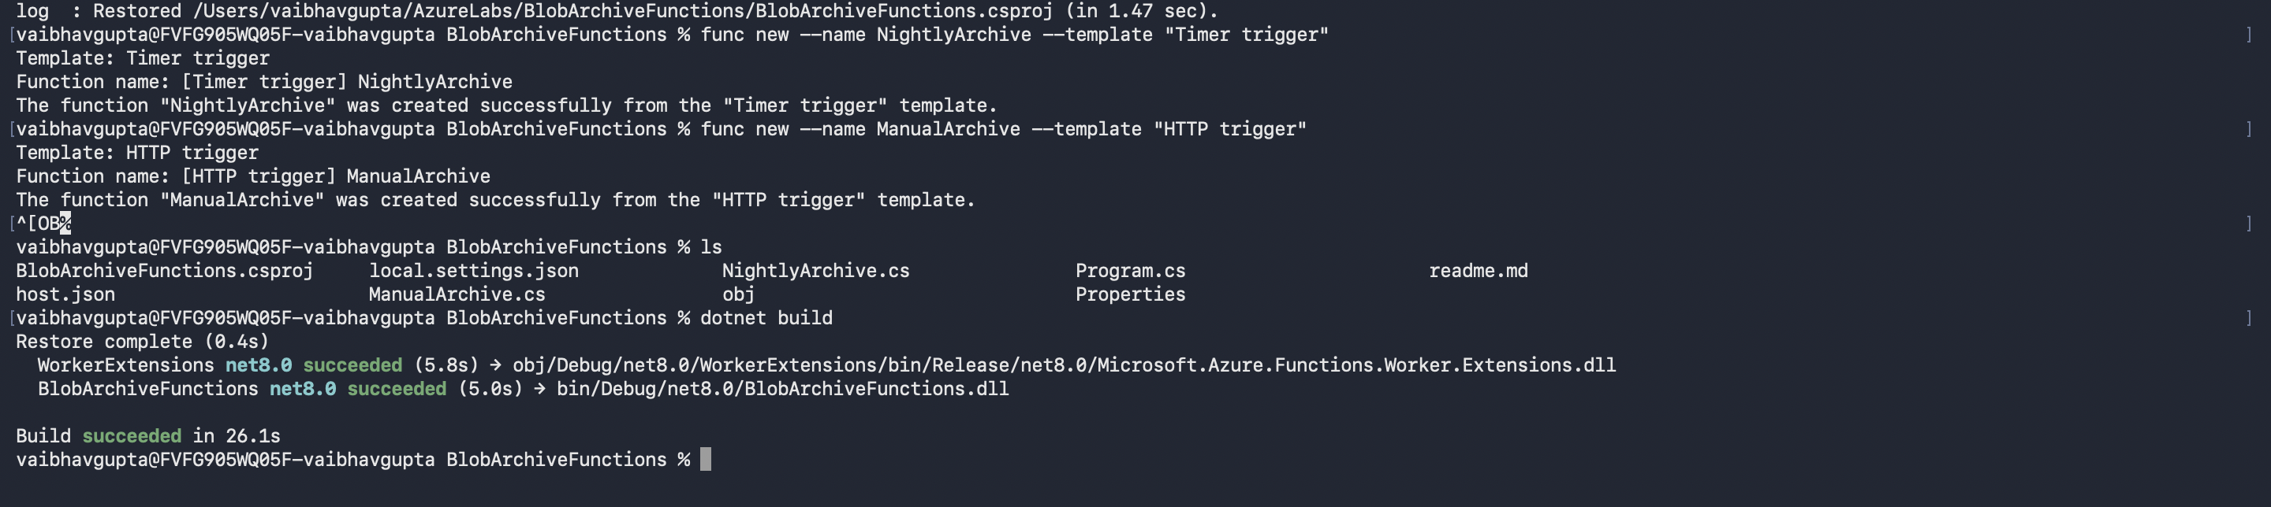

Lab 5: Write the Timer Trigger Function
The Timer Trigger function runs automatically on a cron schedule. You will replace the generated placeholder code with logic that scans the uploads container and moves files older than 7 days to archive.

Step 1 — Create the Archive Service
- Create a new file called BlobArchiveService.cs in the BlobArchiveFunctions folder with the following content:
using Azure.Storage.Blobs;
using Microsoft.Extensions.Logging;

namespace BlobArchiveFunctions;

public class BlobArchiveService
{
private readonly ILogger<BlobArchiveService> _logger;
private readonly string _connectionString;

public BlobArchiveService(ILogger<BlobArchiveService> logger, IConfiguration config)
{
_logger = logger;
_connectionString = config["BlobStorageConnectionString"]
?? throw new InvalidOperationException("BlobStorageConnectionString is not configured.");
}

public async Task<int> ArchiveOldBlobsAsync(int olderThanDays = 7)
{
var serviceClient = new BlobServiceClient(_connectionString);
var uploads = serviceClient.GetBlobContainerClient("uploads");
var archive = serviceClient.GetBlobContainerClient("archive");

await archive.CreateIfNotExistsAsync();

int count = 0;
var cutoff = DateTimeOffset.UtcNow.AddDays(-olderThanDays);

await foreach (var blobItem in uploads.GetBlobsAsync())
{
if (blobItem.Properties.LastModified < cutoff)
{
var sourceBlob = uploads.GetBlobClient(blobItem.Name);
var destBlob = archive.GetBlobClient(blobItem.Name);

await destBlob.StartCopyFromUriAsync(sourceBlob.Uri);
await sourceBlob.DeleteAsync();

_logger.LogInformation("Archived: {BlobName}", blobItem.Name);
count++;
}
}

_logger.LogInformation("Archive run complete. Files moved: {Count}", count);
return count;
}
}

Step 2 — Register the Service in Program.cs
- Open Program.cs and replace its contents with:
using Microsoft.Azure.Functions.Worker;
using Microsoft.Extensions.DependencyInjection;
using Microsoft.Extensions.Hosting;
using BlobArchiveFunctions;

var host = new HostBuilder()
.ConfigureFunctionsWorkerDefaults()
.ConfigureServices(services =>
{
services.AddTransient<BlobArchiveService>();
})
.Build();

host.Run();

Step 3 — Replace the NightlyArchive Function
- Open NightlyArchive.cs and replace its contents with:
using Microsoft.Azure.Functions.Worker;
using Microsoft.Extensions.Logging;

namespace BlobArchiveFunctions;

public class NightlyArchive
{
private readonly BlobArchiveService _archiveService;
private readonly ILogger<NightlyArchive> _logger;

public NightlyArchive(BlobArchiveService archiveService, ILogger<NightlyArchive> logger)
{
_archiveService = archiveService;
_logger = logger;
}

// Runs every day at midnight UTC
// Cron format: {second} {minute} {hour} {day} {month} {day-of-week}
[Function("NightlyArchive")]
public async Task Run([TimerTrigger("0 0 0 * * *")] TimerInfo myTimer)
{
_logger.LogInformation("NightlyArchive triggered at: {Time}", DateTime.UtcNow);
await _archiveService.ArchiveOldBlobsAsync(olderThanDays: 7);
}
}
Tip
The cron expression 0 0 0 * * * means: at second 0, minute 0, hour 0, every day, every month, every day of the week — i.e. midnight UTC daily.

Lab 6: Write the HTTP Trigger Function
The HTTP Trigger lets you call the same archive logic on demand — useful for testing without waiting for midnight. It also accepts an optional query parameter so you can test with a shorter age window.

Step 1 — Replace the ManualArchive Function
- Open ManualArchive.cs and replace its contents with:
using System.Net;
using Microsoft.Azure.Functions.Worker;
using Microsoft.Azure.Functions.Worker.Http;
using Microsoft.Extensions.Logging;

namespace BlobArchiveFunctions;

public class ManualArchive
{
private readonly BlobArchiveService _archiveService;
private readonly ILogger<ManualArchive> _logger;

public ManualArchive(BlobArchiveService archiveService, ILogger<ManualArchive> logger)
{
_archiveService = archiveService;
_logger = logger;
}

[Function("ManualArchive")]
public async Task<HttpResponseData> Run(
[HttpTrigger(AuthorizationLevel.Anonymous, "post")] HttpRequestData req)
{
// Optional: pass ?days=1 to archive files older than 1 day (useful for testing)
var query = System.Web.HttpUtility.ParseQueryString(req.Url.Query);
int days = int.TryParse(query["days"], out var d) ? d : 7;

_logger.LogInformation("ManualArchive triggered — archiving files older than {Days} day(s).", days);

int count = await _archiveService.ArchiveOldBlobsAsync(olderThanDays: days);

var response = req.CreateResponse(HttpStatusCode.OK);
await response.WriteStringAsync($"Archive complete. Files moved: {count}");
return response;
}
}

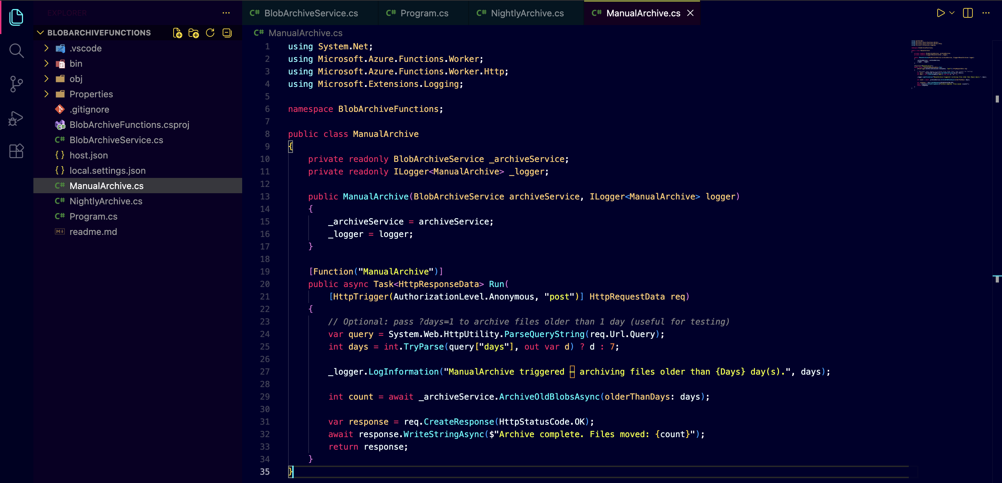

Lab 7: Test Locally
Before deploying to Azure, test the functions on your machine. The local settings file acts as a stand-in for Azure app settings when running locally.

Step 1 — Configure local.settings.json
- Open local.settings.json (in the BlobArchiveFunctions folder) and replace its contents with your actual connection string:
{
"IsEncrypted": false,
"Values": {
"AzureWebJobsStorage": "UseDevelopmentStorage=true",
"FUNCTIONS_WORKER_RUNTIME": "dotnet-isolated",
"BlobStorageConnectionString": "PASTE-YOUR-CONNECTION-STRING-HERE"
}
}
Important
Replace PASTE-YOUR-CONNECTION-STRING-HERE with the value from echo %CONN_STRING% in your cmd.exe session. local.settings.json is already in .gitignore by default — never commit it to source control.

Step 2 — Build the Project
dotnet build

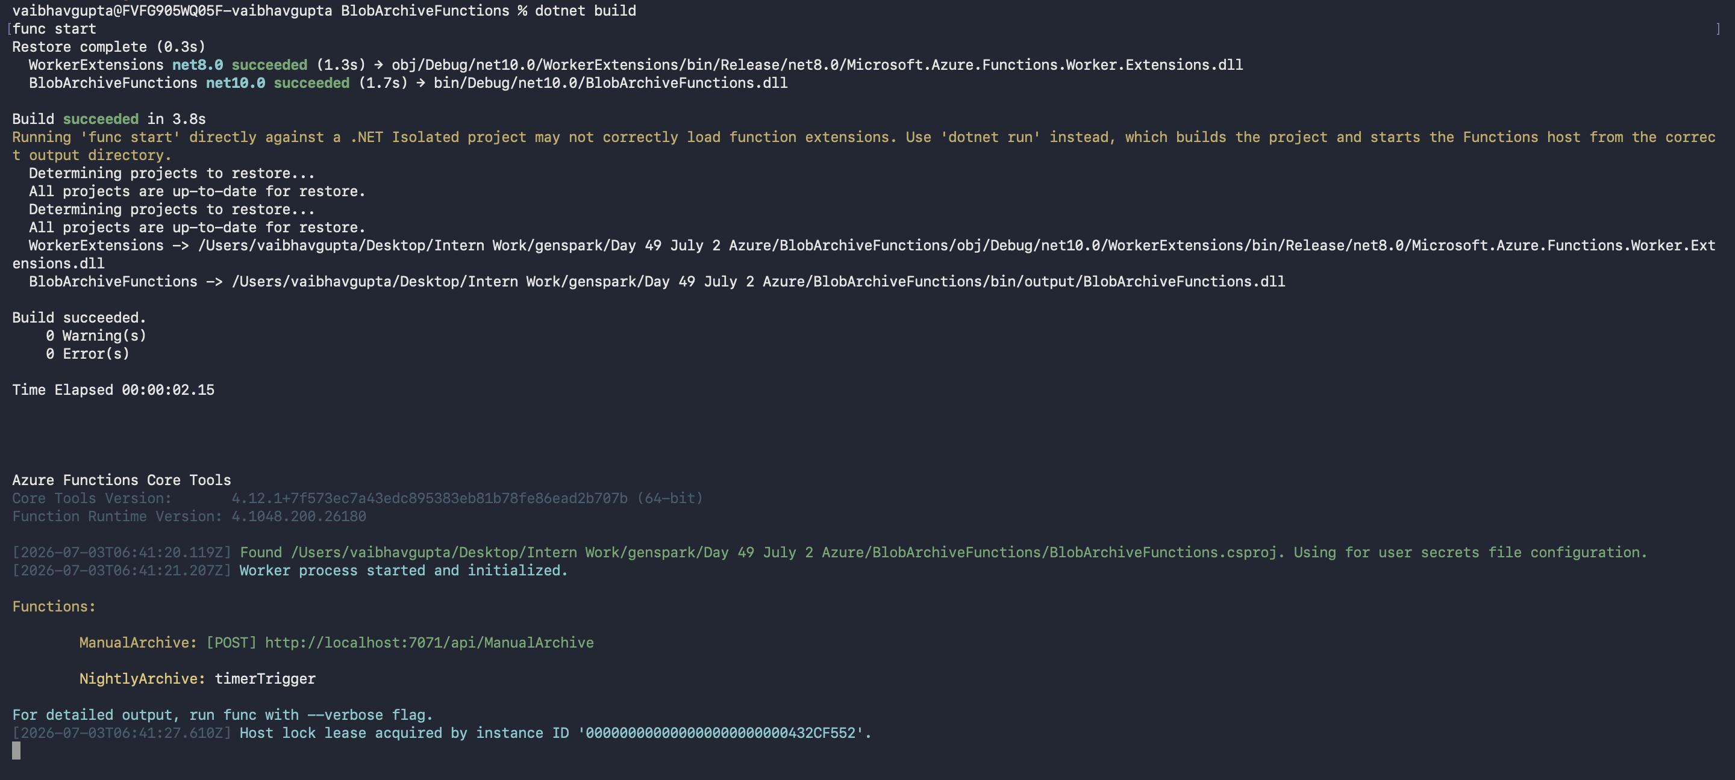

Step 3 — Start the Function App
func start
The Functions runtime will start and print the URLs for both functions. Look for two lines like:
NightlyArchive: timerTrigger
ManualArchive: [POST] http://localhost:7071/api/ManualArchive



Step 4 — Upload a Test File to Blob Storage
- Open a SECOND cmd.exe window (leave func start running in the first). Upload a test file:
az storage blob upload ^
--account-name %SA_NAME% ^
--container-name uploads ^
--name testfile.txt ^
--data "hello from the lab" ^
--auth-mode login
Tip
For testing the archive logic without waiting 7 days, you will use the ?days=0 query parameter in the next step — this archives ALL files regardless of age.

Step 5 — Trigger ManualArchive
- In the second cmd.exe window, call the HTTP trigger with days=0 to archive everything immediately:
curl -X POST "http://localhost:7071/api/ManualArchive?days=0"

Expected Result
Expected response: Archive complete. Files moved: 1

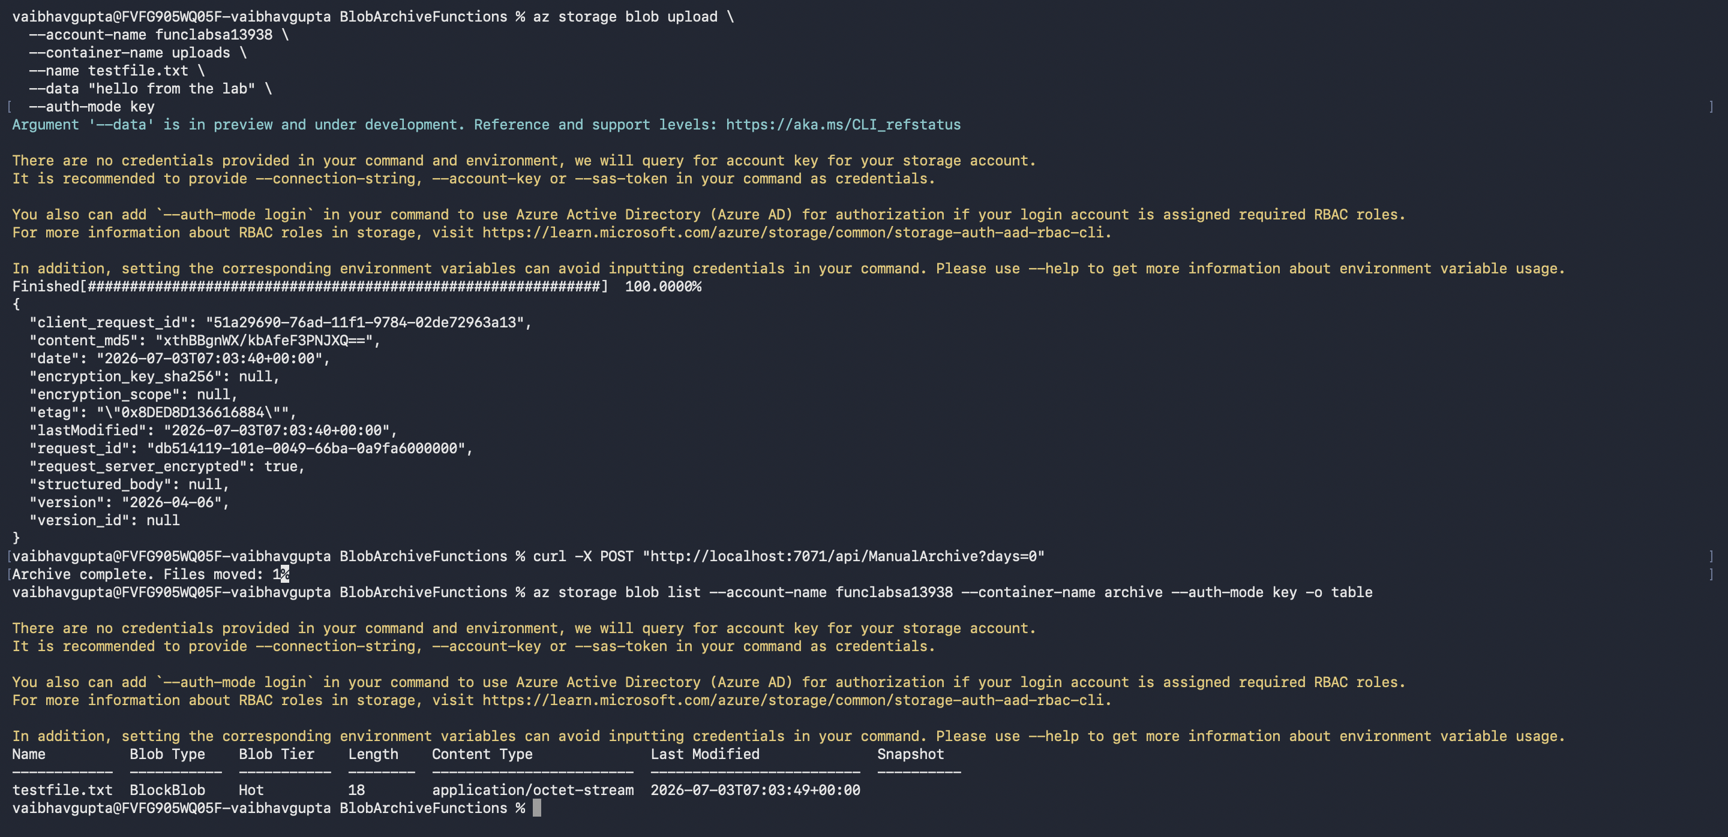

Step 6 — Verify the Blob Moved
- Confirm testfile.txt is now in the archive container and gone from uploads:
az storage blob list --account-name %SA_NAME% --container-name archive --auth-mode login -o table
az storage blob list --account-name %SA_NAME% --container-name uploads --auth-mode login -o table

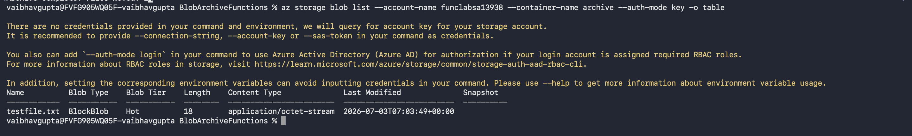
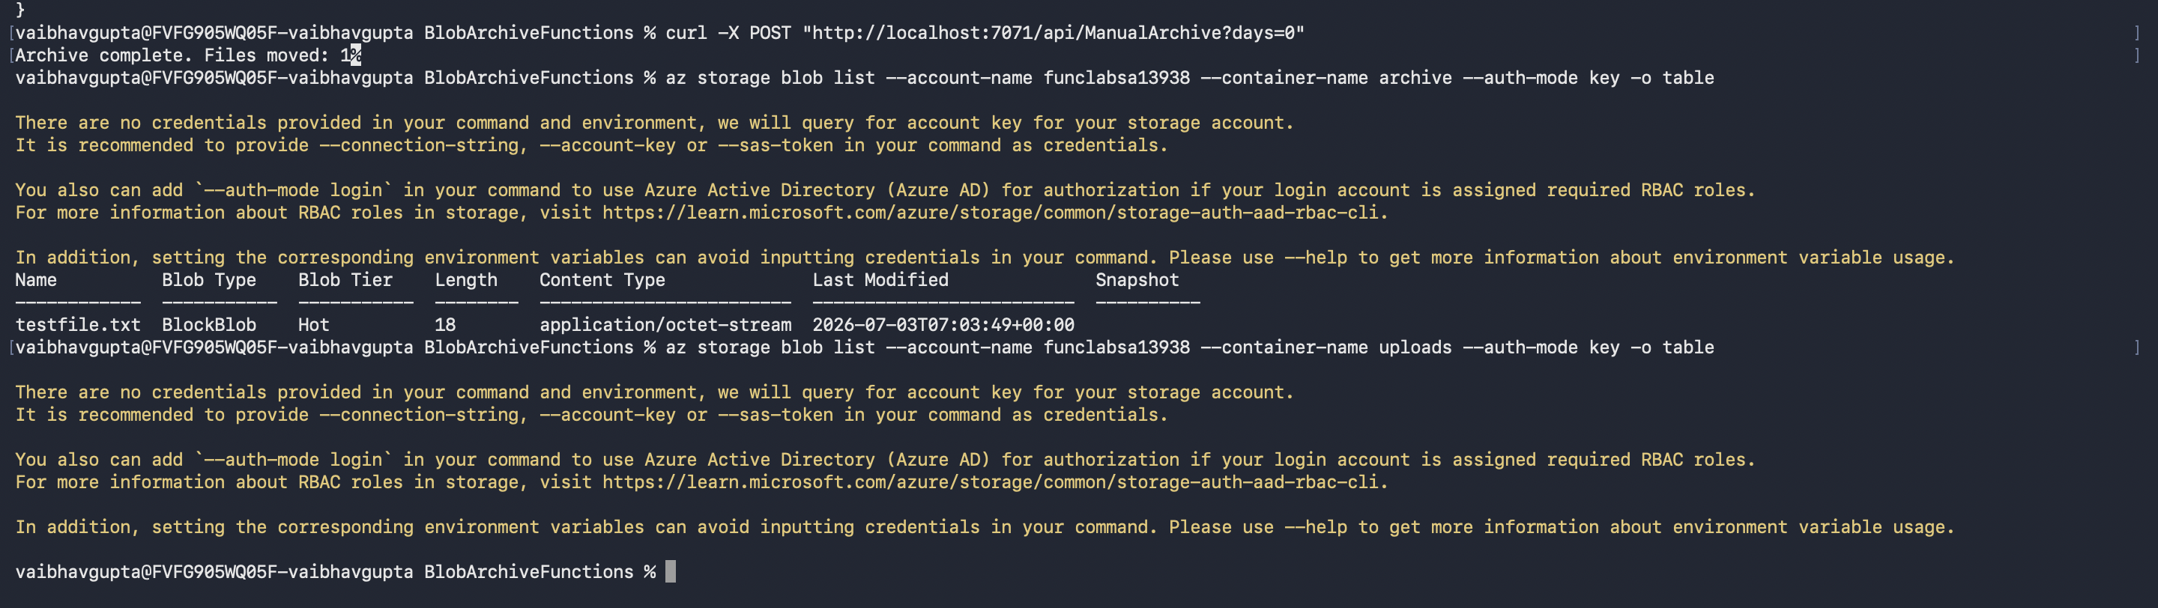

Lab 8: Deploy to Azure
Now deploy the Function App to Azure. The deployed version will read the connection string from Key Vault via a Key Vault Reference — a special app setting syntax that tells Azure to fetch the value automatically. Your function code stays exactly the same.

Step 1 — Create the Function App in Azure
- Stop func start in the first window (Ctrl+C), then run:
az functionapp create ^
--name %FUNC_NAME% ^
--resource-group %RG% ^
--storage-account %SA_NAME% ^
--consumption-plan-location %LOCATION% ^
--runtime dotnet-isolated ^
--functions-version 4 ^
--os-type Windows

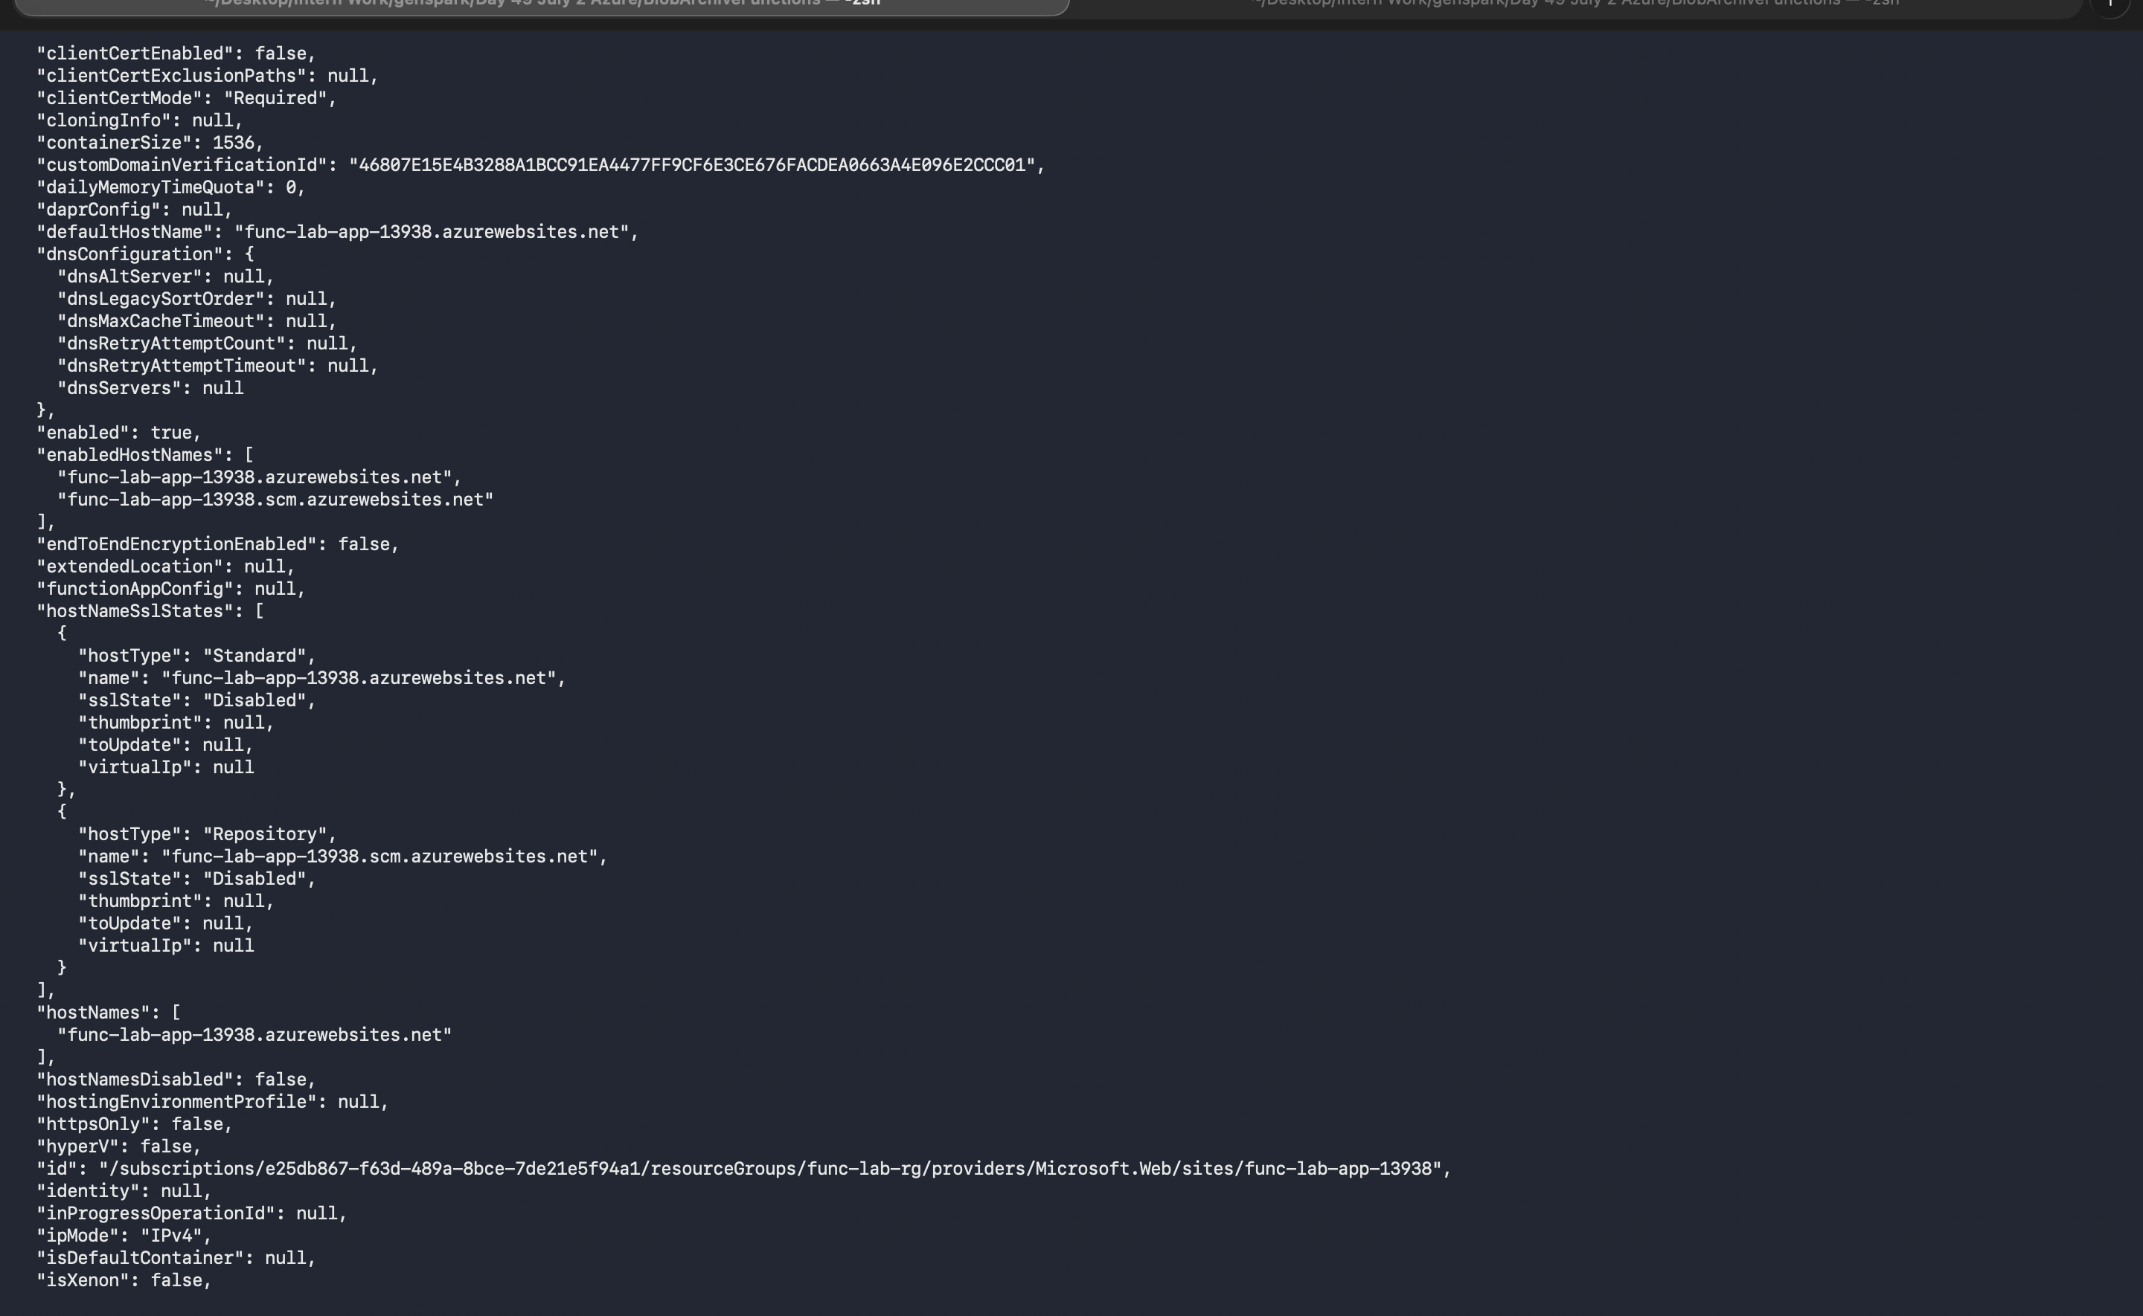
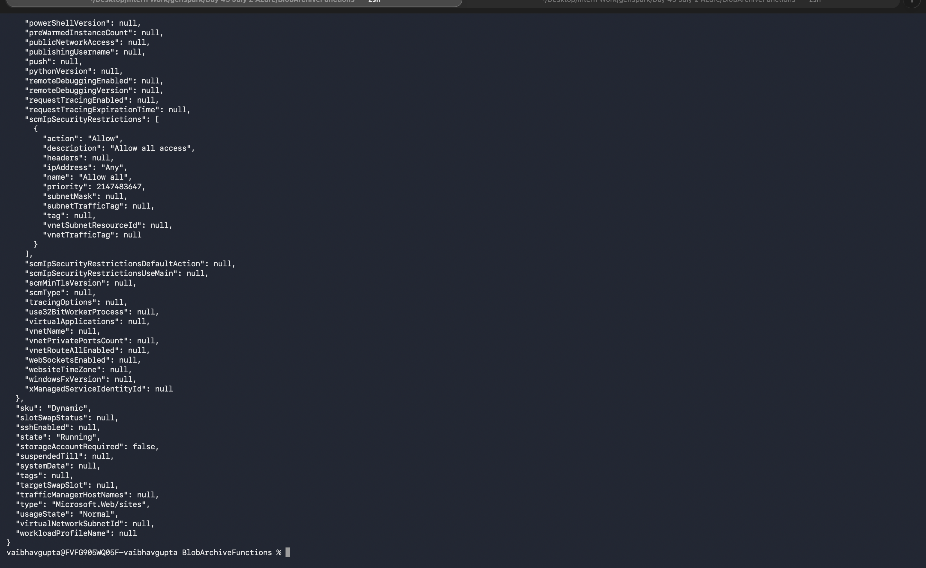

Function App URL (https://FUNC_NAME.azurewebsites.net) | func-lab-app-13938.azurewebsites.net ____________________________________________
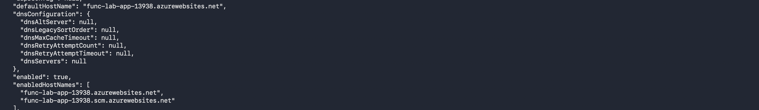

Step 2 — Assign a Managed Identity
az functionapp identity assign --name %FUNC_NAME% --resource-group %RG%
- Capture the identity's principal ID:
for /f "delims=" %a in ('az functionapp identity show --name %FUNC_NAME% --resource-group %RG% --query principalId -o tsv') do set PRINCIPAL_ID=%a

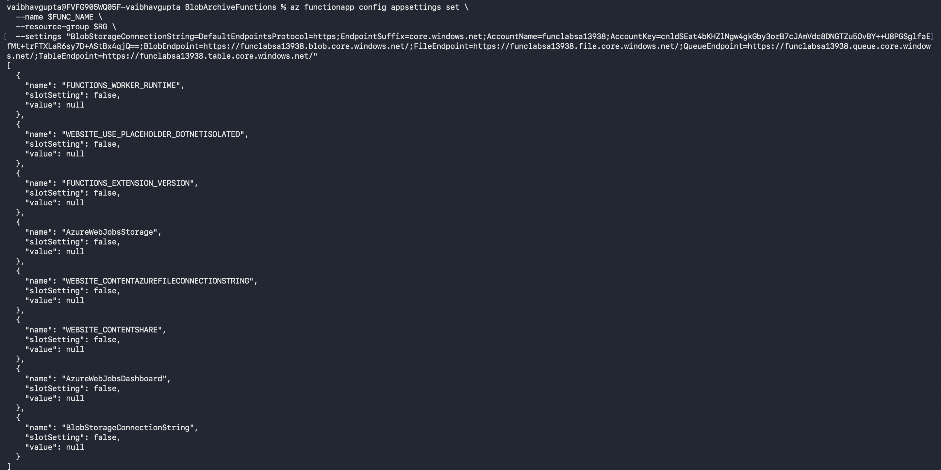

Step 3 — Grant the Identity Key Vault Access
az keyvault set-policy ^
--name %KV_NAME% ^
--object-id %PRINCIPAL_ID% ^
--secret-permissions get list

Step 4 — Set the Key Vault Reference App Setting
Instead of pasting the connection string directly, use a Key Vault Reference. Azure resolves the @Microsoft.KeyVault(...) syntax automatically and injects the real value at runtime:
az functionapp config appsettings set ^
--name %FUNC_NAME% ^
--resource-group %RG% ^
--settings "BlobStorageConnectionString=@Microsoft.KeyVault(VaultName=%KV_NAME%;SecretName=BlobStorageConnectionString)"
Tip
This is Key Vault Reference syntax. Your function code reads BlobStorageConnectionString exactly as before — Azure quietly swaps in the real value from Key Vault before handing it to your code. No code changes required.

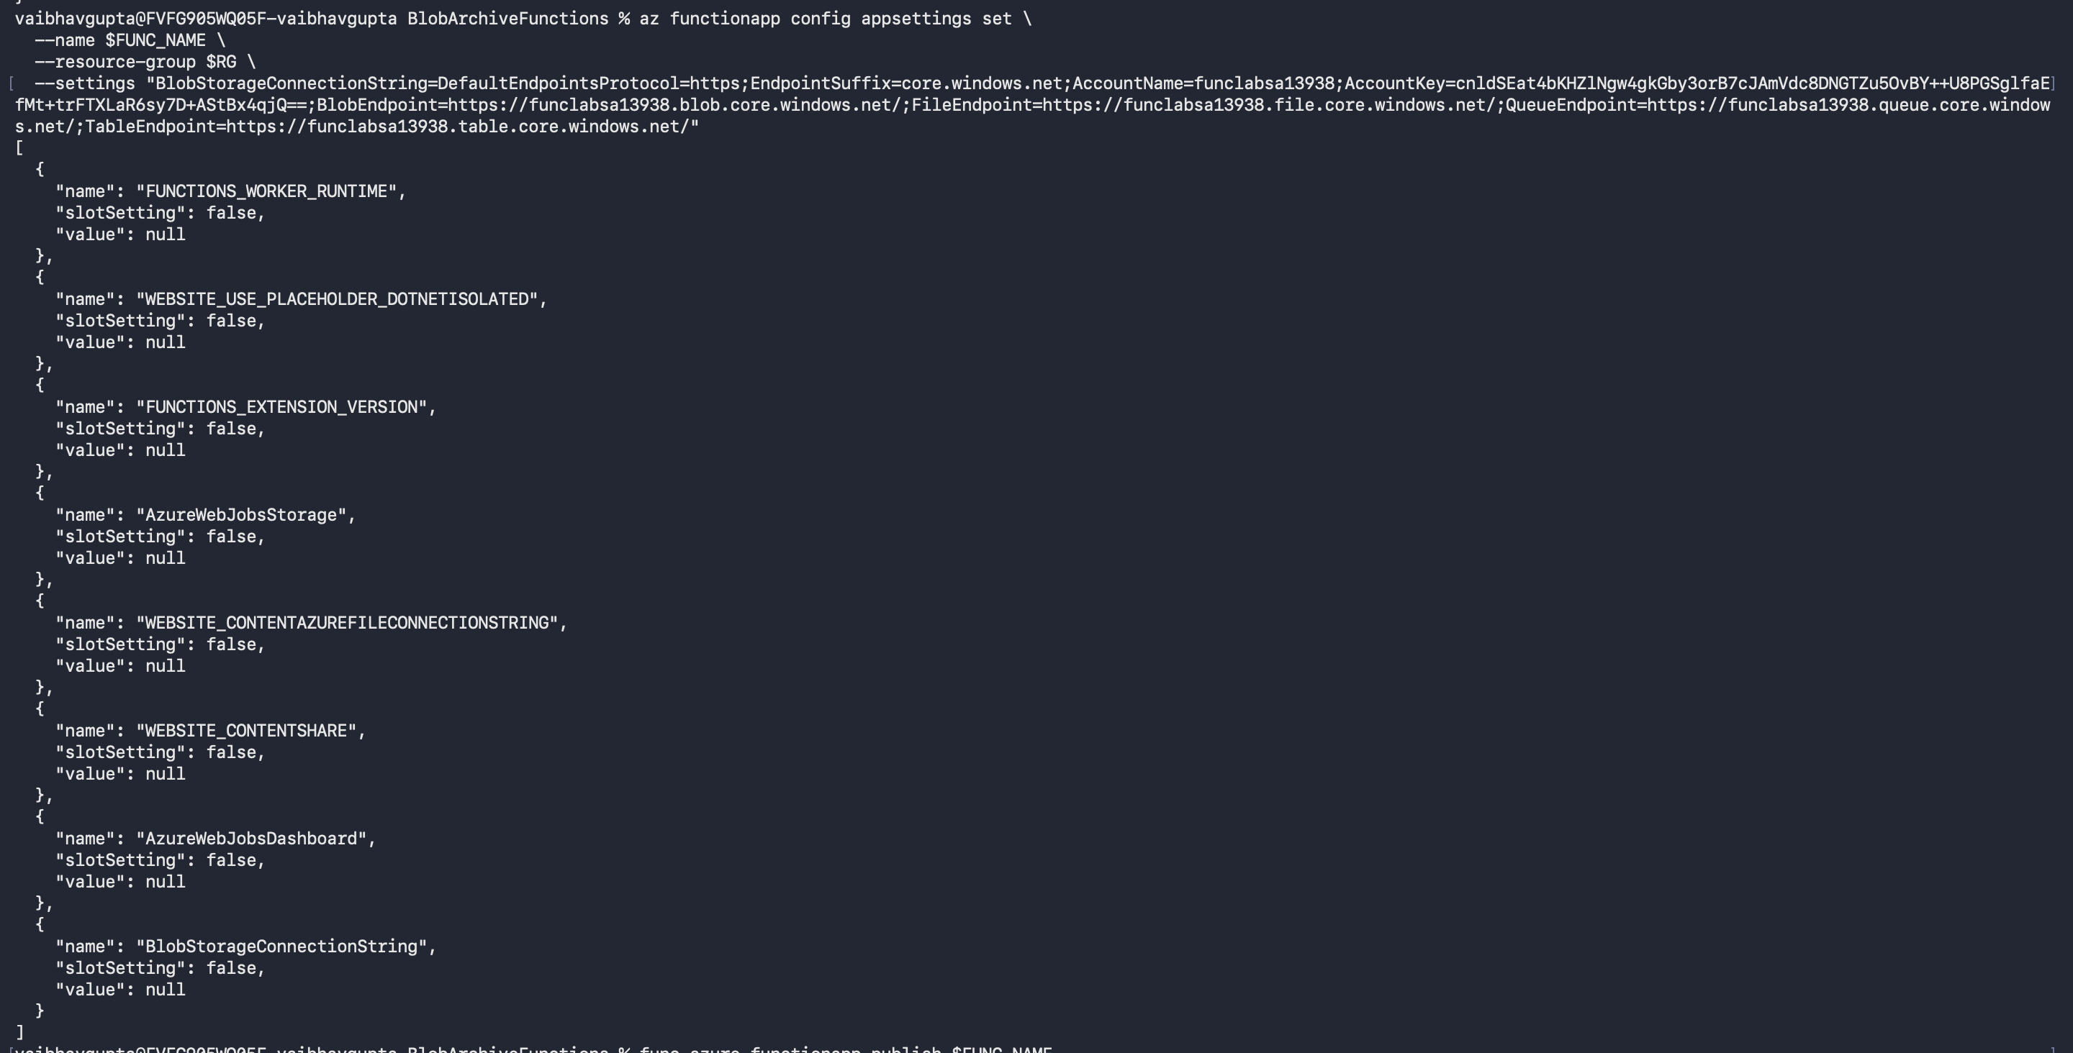

Step 5 — Publish and Deploy
func azure functionapp publish %FUNC_NAME%

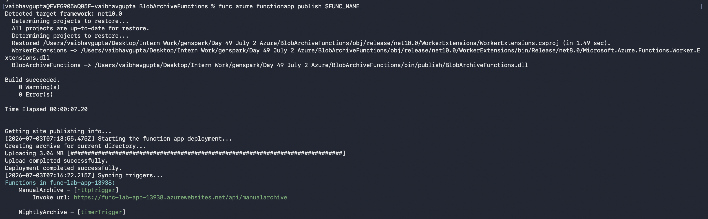

Step 6 — Test the Deployed HTTP Trigger
- Upload a test file to blob storage first:
az storage blob upload ^
--account-name %SA_NAME% ^
--container-name uploads ^
--name cloudtest.txt ^
--data "uploaded for cloud test" ^
--auth-mode login
- Trigger the ManualArchive function in the cloud:
curl -X POST "https://%FUNC_NAME%.azurewebsites.net/api/ManualArchive?days=0"

Expected Result
Expected response: Archive complete. Files moved: 1

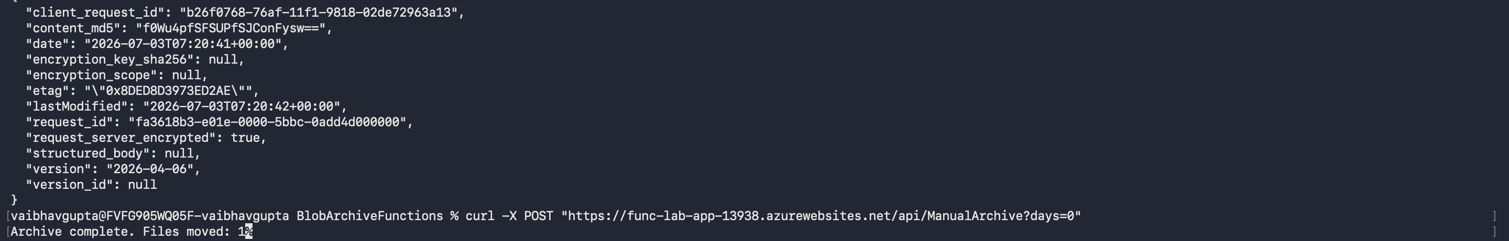 curl response from the deployed function — Archive complete. Files moved: 1

- Verify the blob moved to archive:
az storage blob list --account-name %SA_NAME% --container-name archive --auth-mode login -o table

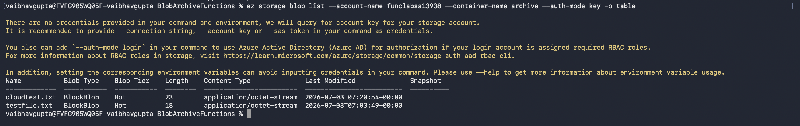

Lab 9: Cleanup
Important
This permanently deletes all resources. Only run when you are completely finished with the lab.
az group delete --name %RG% --yes --no-wait

Screenshot
az group delete accepted — all resources queued for deletion

Reflection Questions

1. What is the difference between a Timer Trigger and an HTTP Trigger? When would you choose one over the other?
A Timer Trigger runs automatically on a set schedule, while an HTTP Trigger runs only when someone specifically calls its web URL. Choose a Timer for routine background tasks (like nightly cleanups) and an HTTP trigger for on-demand actions (like a user clicking a button).
2. What does the cron expression 0 0 0 * * * mean? How would you change it to run every Monday at 6:00 AM?
The expression 0 0 0 * * * means the function runs every day exactly at midnight. To change it to run every Monday at 6:00 AM, you would use the expression 0 0 6 * * 1.
3. What is a Key Vault Reference? How is it different from storing the connection string directly as an app setting?
A Key Vault Reference is a pointer that tells the app to securely fetch a secret from a digital vault only when it needs it. This is much safer than saving the raw, readable password directly in the app's standard settings.
4. The NightlyArchive function runs at midnight UTC. If your business is in India (IST = UTC+5:30), what cron expression would run it at midnight IST?
Since IST is 5.5 hours ahead of UTC, midnight in India is actually 6:30 PM (18:30) the day before in UTC. The correct cron expression to run at midnight IST is 0 30 18 * * *.

Common Errors
Error | Fix
func: command not found | Azure Functions Core Tools not installed. Run: npm install -g azure-functions-core-tools@4 --unsafe-perm true
Variable not set (%SA_NAME% prints literally) | Session was closed. Re-run all set commands from Lab 1 using your saved SUFFIX value
BlobStorageConnectionString is not configured | Check local.settings.json — the value must be the actual connection string, not a placeholder
403 on Key Vault (deployed) | Managed Identity access policy not set or wrong principalId — re-run az keyvault set-policy with the correct PRINCIPAL_ID
Key Vault Reference shows as literal string | The Function App identity was not granted get permission on Key Vault secrets — check Step 3 of Lab 8
func start fails — port in use | Another process is using port 7071. Close it or run: func start --port 7072
dotnet build errors on the function files | Ensure the func new command ran successfully and both .cs files exist in the project folder
Blob not archived — count is 0 | The file is newer than the days threshold. Test with ?days=0 to archive all files regardless of age

